IGCSE MATHEMATICS TIPS

1. **READ THE QUESTIONS/ INSTRUCTIONS THOROUGHLY:**

*Most students lost their points due to not fully reading the questions. Everything in the question is important.*

1. **ACCURACY:**

*Most questions require answers rounded to 3 significant figures, except for angles (1 decimal place) and other specified questions (rounded to 2 decimal places, mostly).*

1. **Only round the final answer, not the intermediate values:**

*Using rounded values could lead to incorrect answers for the next question. So be careful with these tricky things.*

1. **Solving Quadratic Equations**

*Don't waste time factorising quadratic equations that result in three or more decimal places. Instead, use the quadratic formula, specifically the discriminant.*

1. **Understand the Syllabus:**

*Familiarise yourself with the IGCSE Math syllabus. This will help you know what topics to focus on and the depth of understanding required.*

1. **Show Your Work:**

*Clearly show your working out, especially for longer problems. This can earn you partial credit even if your final answer is incorrect.*

1. **Use the Marking Scheme:**

*Familiarise yourself with the marking scheme. This can give you insights into how marks are allocated for each question.*

1. **Don't use the sine or cosine rule for right triangles:**

*Use SOH, CAH, TOA for right triangles.*

1. **Units :**

*Include units with your answers if they are not given on the paper.*

1. **Time management:**

*If you are stuck on a question, don't waste too much time trying to answer it - go on to the next question and come back to the one you stuck on at the end.*

1. **Memorise and understand the command words:**

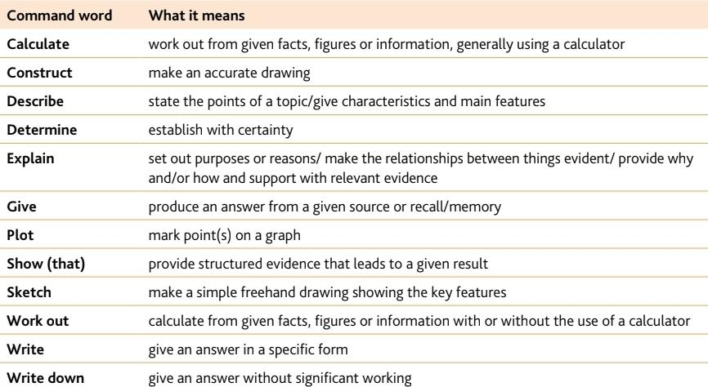

1. **For one-point questions:**

*You only need to provide your answer without showing all your work.*

1. **NOT TO SCALE :**

*It means that you cannot find the answer by measuring the diagram.*

1. **Be harsh to yourself while you are practicing.**

Feel free to ask anytime 😃

Ig : mr_laa

E-Mail : [26b_maral.ts@gmail.com](mailto:26b_maral.ts@gmail.com)